ASI ANYWHERE Security
ASI anywhere gives access anywhere, anytime via an internet connection to customers and outside employees.
Menus and submenus may be secured by user login id.

- Order Status
- Inventory Level Checks
- Account Balance
- Credit History with Aged Invoices
- Review and Reprint Signed Bill of Lading
- Review and Reprint Invoice Form in .PDF Format
- Release Deliveries with new dates, quantity and purchase order number.
- Request for Quotes via 3D Style Image
- Finished Goods Customer Inventory Reports
- Order Backlog Reporting
- Add New Orders
- Email Confirmations

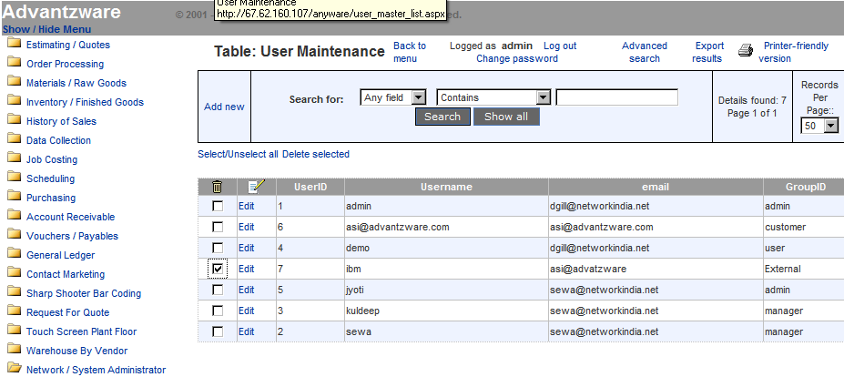

ASI ANYWHERE SECURITY

The first step to implement ASI anywhere is to define users and their access rights.
External users are limited to what they see and what changes they can make. Whereas an internal user such as an outside sales person or inside customer service analyst are only limited by security rights. Once defined, the login and password protects your critical corporation information. Underlying this security is the world renowned Microsoft SQL database combined with the web security of Progress software’s application server, which allows 25 to unlimited users simultaneous access to information in real time. Note: please do not delete the user group External. Press the keys N-U in version 10.0. Click on View User, and then press the Add button on the bottom right. This will allow you to add new users for Advantzware as well as the web. You can use existing users, if already set up in the Advantzware system.

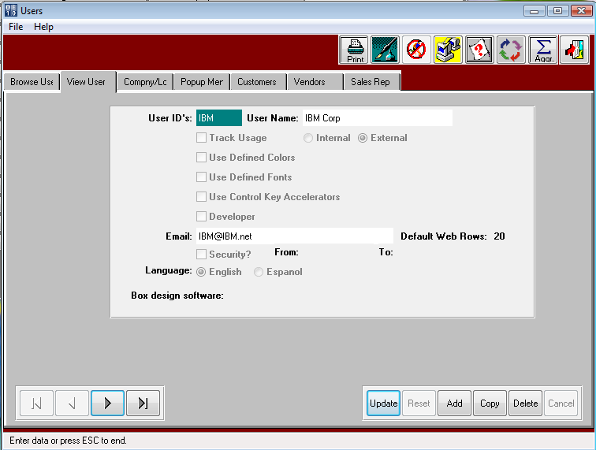

SAVING new users will require that you press SAVE. The system will then ask you for the Initial Password. Please type this in the box and then press enter.

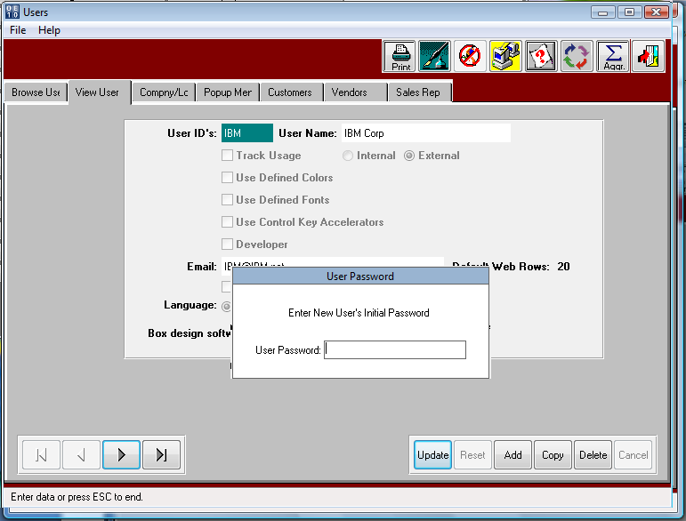

CUSTOMERS and VENDORS per USER ID.

WEB users are limited to customer and vendor data. The CUSTOMER folder will limit which customer codes will be available during the use of the ASI ANYWARE software. Likewise, the VENDOR folder will limit which vendor’s information will be available via the ASI ANYWARE software. To add Customers for this user ID, press the Add button on the bottom of the CUSTOMERS folder. To add Vendors, click the VENDOR folder and add vendors via the ADD button on the bottom.

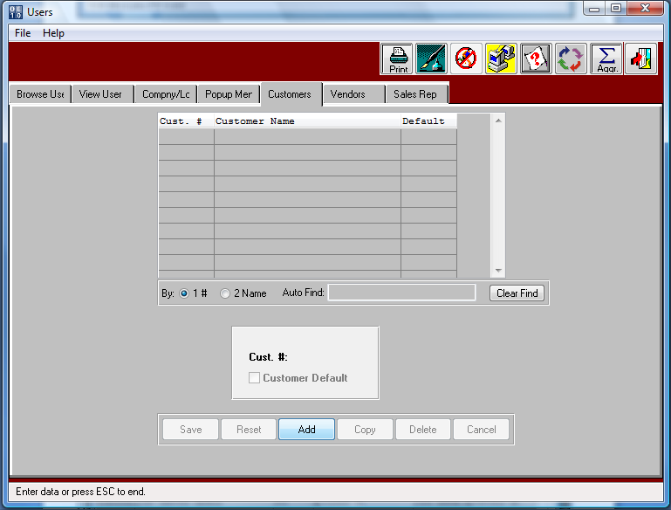

CUSTOMERS and VENDORS per USER ID.

After you press Add you can then type in the Customer Code or press F1 to search for Customers.

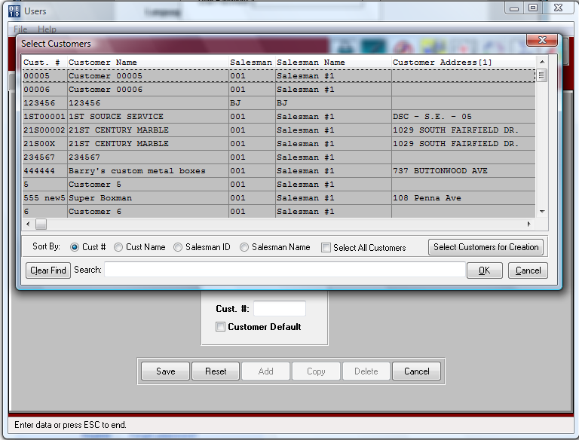

If the user ID is for an outside salesperson, then many customers may be entered in the customer folder.
If the user ID is an external customer’s employee, then only put their company code here.
The menus that display for a user ID are defined in the security in ASI ANYWARE.
In this example, the user ID IBM in an employee that can only access information for IBM1000.

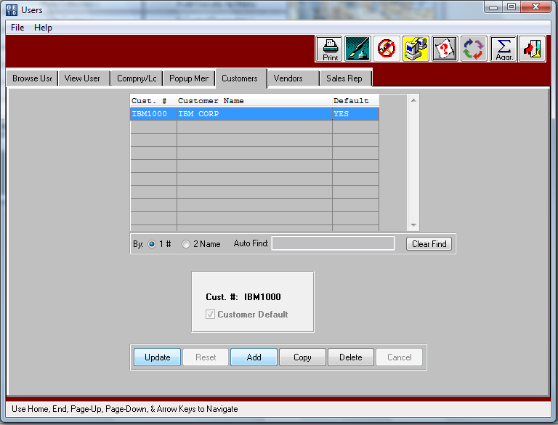

Now you may log into ASI Anyware on the internet. You will see the below Login in screen. Simply put in the username and the password we just created.

The Login ID and password limits external users to only their customer information.
The network security also limits what menu options are available by user.

We will be logging in as the admin, so that we can set up IBM in the system.

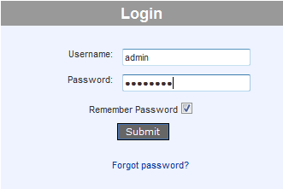

After signing in you will see the menu to the left and then you must press the Network / System Administrator and then User Group Maintenance. This will allow us to make sure there are the correct groups here and each user that gets put into this system must then be put in one of these groups.

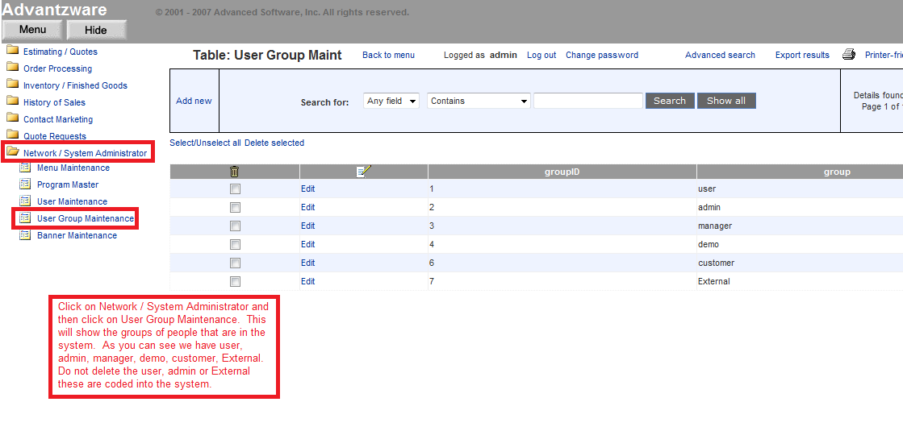

The User Maintenance file will display valid user groups. Press the menu option and select IBM (as an example) by clicking the arrow next to IBM. This will highlight this user and you can press View User to change any of IBM’s info.

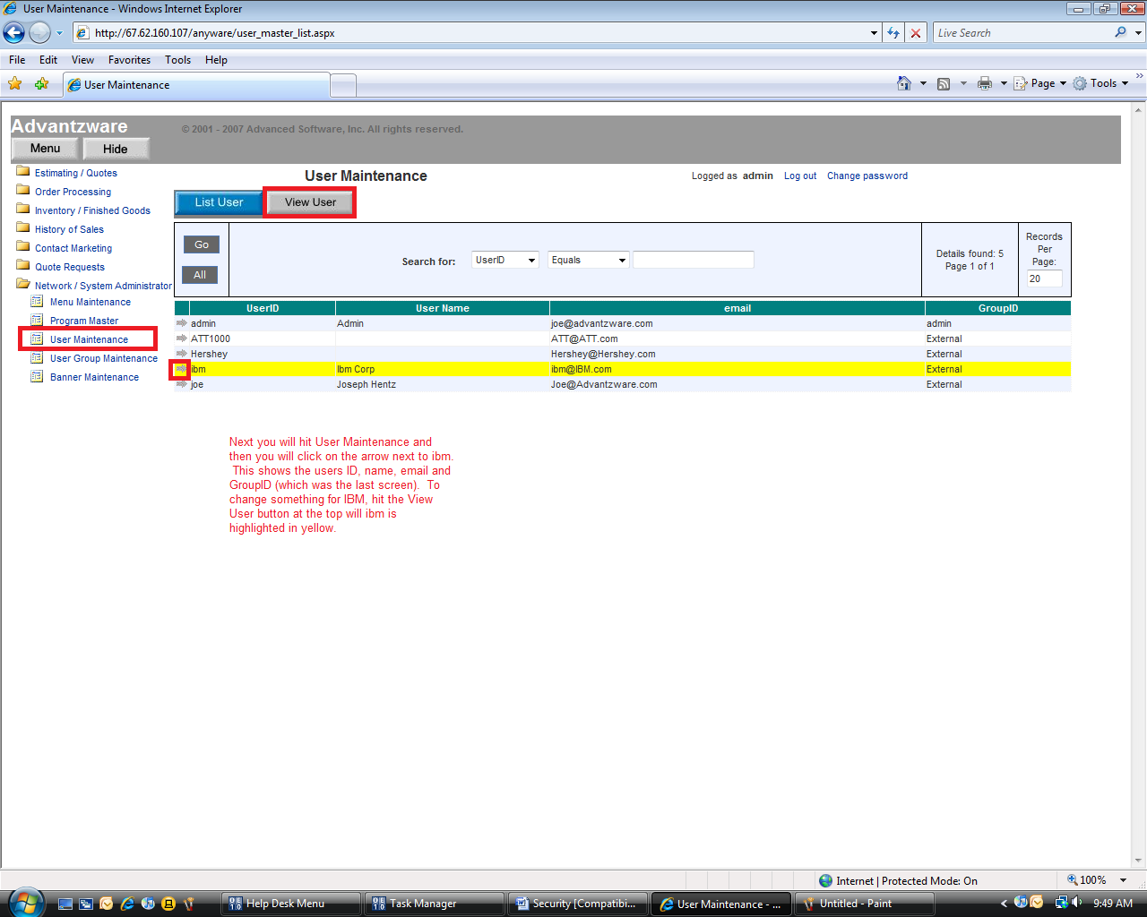

To add a new user just press the View User button and then push add.

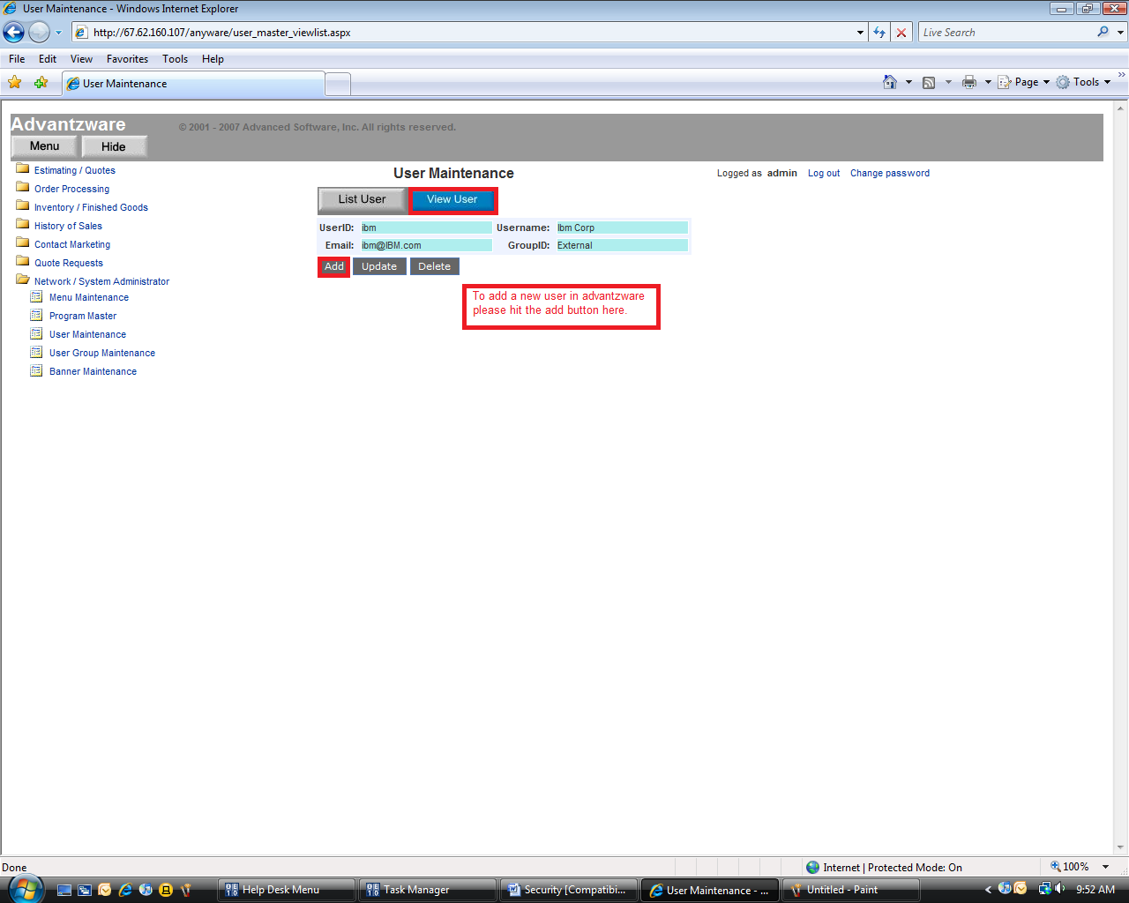

You can then press Menu Maintenance and this will show you the menus that each user group can see and access. We had IBM as an External (in GroupID/Security Group)….so IBM can see Order Processing, Inventory / Finished Goods, Contact Marketing and Quote Requests. You can go even further and allow/dis-allow users certain Submenu options, with a menu.

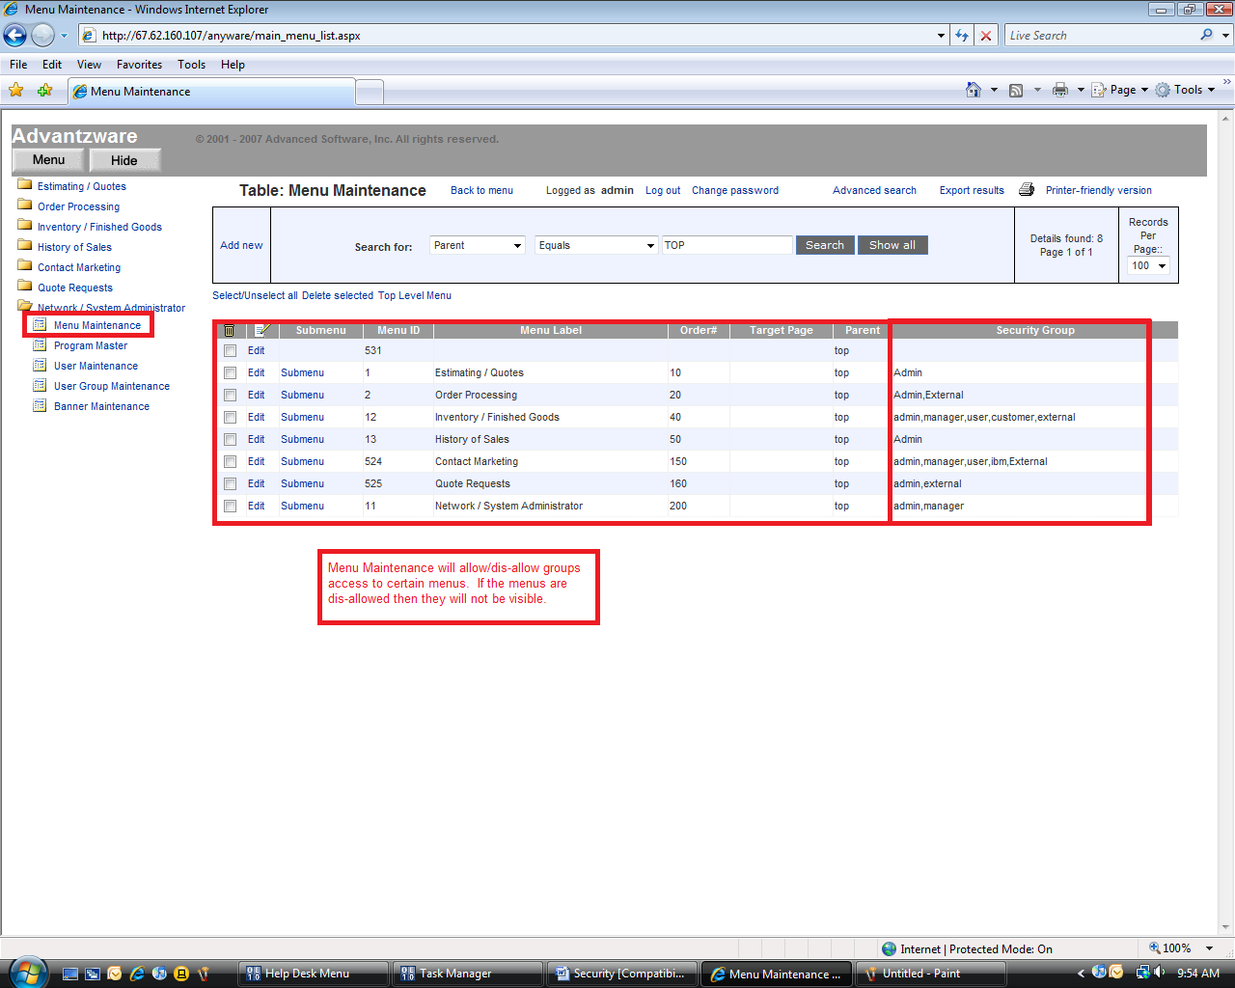

To edit this you must click in the check box and then press edit for the menu option you want to edit.
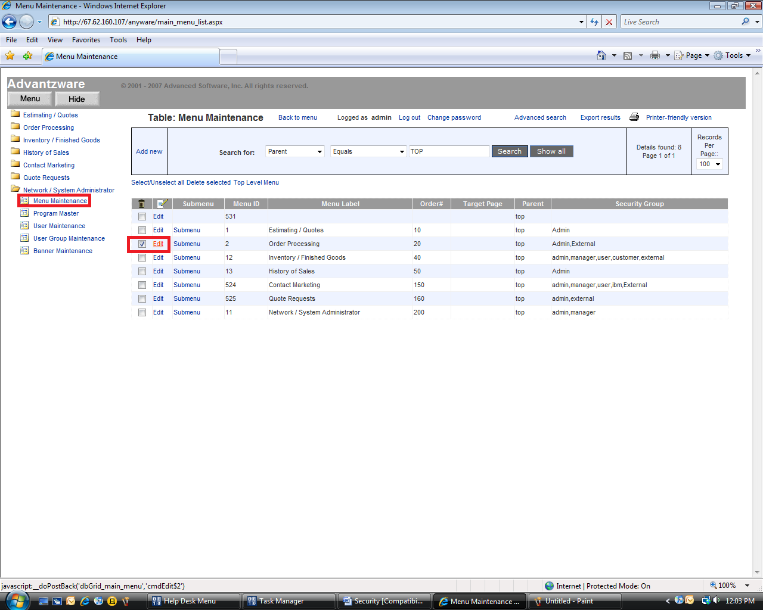
NOTE: Only change the Security Group….

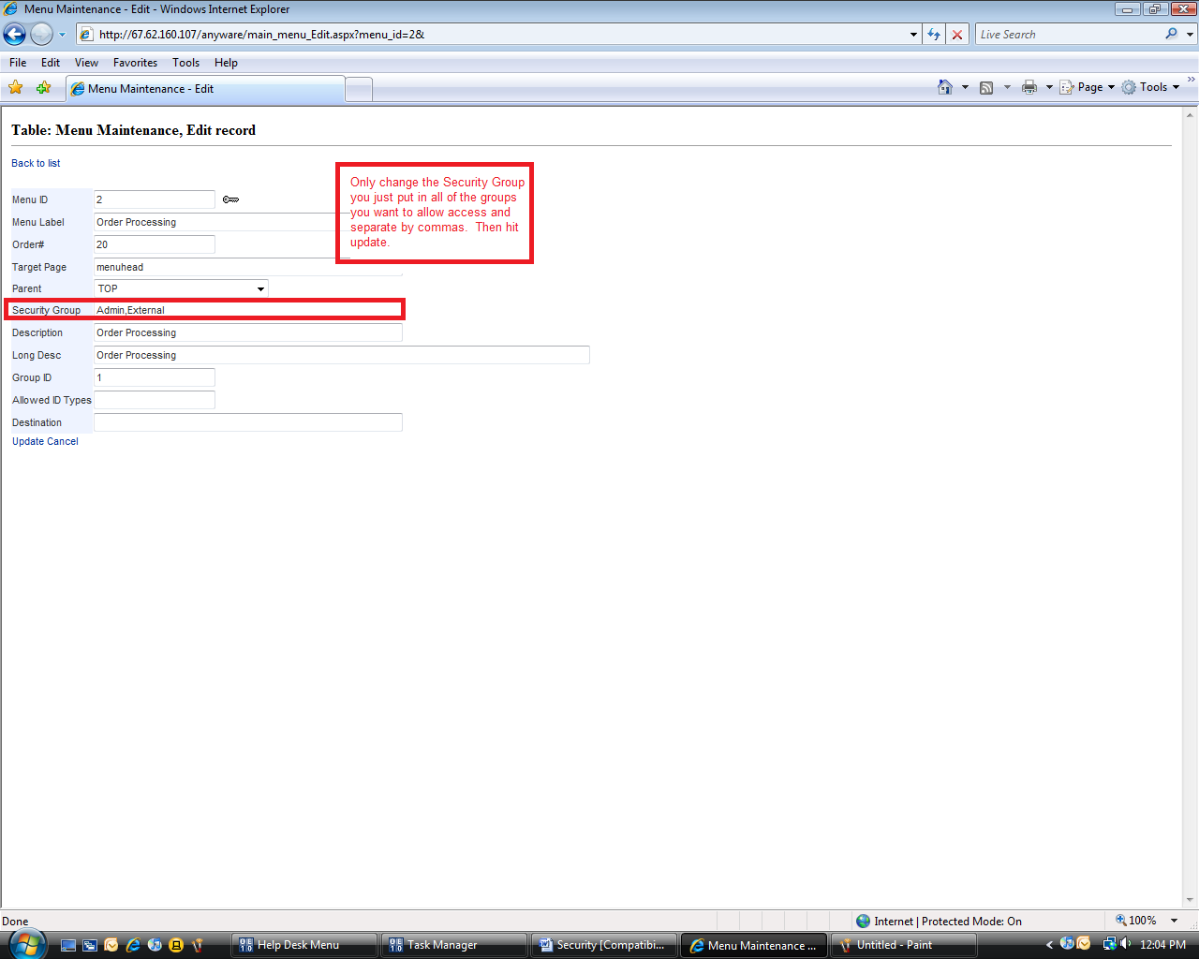

To check to make sure this works we log out and then sign in as IBM.

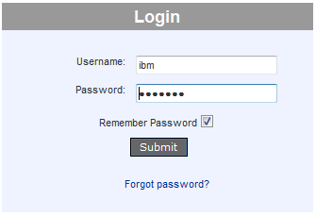

You will notice that only the menu options we allowed are shown below: Order Processing, Inventory / Finished Goods, Contact Marketing and Quote Requests.
